EXPERIMENT: FLIGHT RESERVATION SYSTEM USING SaaS
EXPERIMENT-1

Aim
To create a simple cloud-based Flight Reservation System using a Software as a Service (SaaS) model. The application allows users to select trip type, enter source and destination, choose departure and return dates, select travelers and travel class, choose fare type, and specify domestic or international flights.
Algorithm
- Start the application.
- Display the flight reservation form.
- Ask the user to select One Way or Round Trip.
- Get the From and To locations.
- Get the departure date and, for a round trip, the return date.
- Get the number of travelers and travel class.
- Ask the user to select the fare type.
- Ask the user to select Domestic or International flight.
- Validate that required fields are entered and that the source and destination are different.
- If Round Trip is selected, check that the return date is not earlier than the departure date.
- Display the entered reservation details and a confirmation message.
- Stop.

Pseudocode
START

Display "Flight Reservation System"

Enter Trip Type
Enter From
Enter To
Enter Departure Date
Enter Travelers
Enter Class
Enter Fare Type
Enter Flight Type

Display "Flight Details"

Display Trip Type
Display From
Display To
Display Departure Date
Display Travelers
Display Class
Display Fare Type
Display Flight Type

Display "Reservation Successful"

STOP

Output

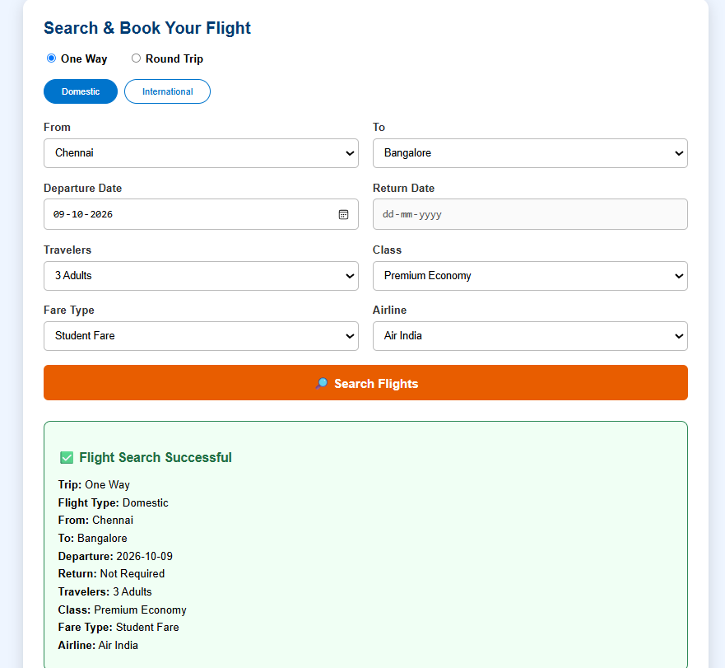
Result
Thus, a simple cloud-based Flight Reservation System was designed to demonstrate the SaaS model. The system accepts flight search details, validates the required inputs, and displays the reservation summary. It can be hosted on a cloud platform so users can access it through a web browser.

EXPERIMENT-2
Aim
To create a simple cloud-based Property Buying and Rental Application for Chennai city using HTML, demonstrating the SaaS (Software as a Service) model with options such as Buy, Rent, Commercial, Rental Agreement, Area, Place, Price Range, and Property Value.
Algorithm
- Start the application.
- Display the Property Buying and Rental form.
- Select the property type: Buy, Rent, or Commercial.
- Select the Rental Agreement option.
- Enter the property Area.
- Select the property location in Chennai.
- Select the Price Range.
- Enter the Property Value.
- Select the required BHK.
- Click the Search Property button.
- Validate the entered details.
- Display the property details.
- Stop the application.

Pseudo Code
START
Open Property Application
Select Buy / Rent / Commercial
Enter Rental Agreement
Enter Area
Select Place
Select Price Range
Enter Property Value
Select BHK
Click Search
Display Property Details
STOP
Output
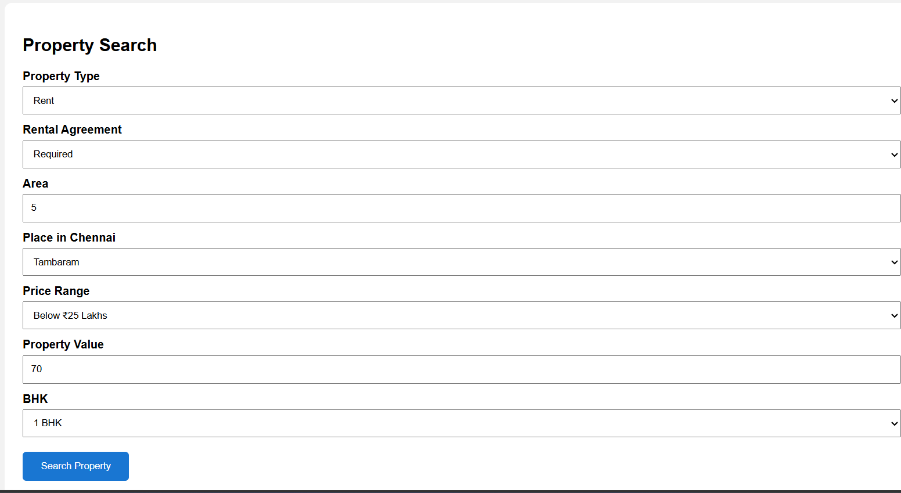
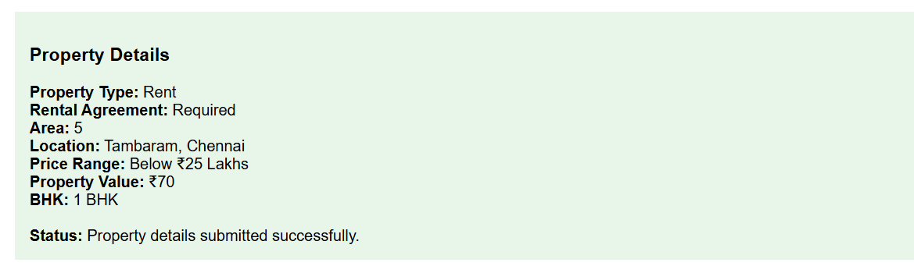
Result:
The Property Buying and Rental SaaS application was successfully created using HTML. The application allows users to enter property details such as Buy/Rent/Commercial, Rental Agreement, Area, Chennai location, Price Range, Property Value, and BHK, and displays the submitted property information successfully.

EXPERIMENT-3
Aim
To create a simple cloud-based Car Booking Reservation System using HTML to demonstrate SaaS, with options such as From, To, Rental, Out Station, Package Type, Hours/Days, and Car Type.
Algorithm
- Start the application.
- Select the booking type.
- Enter the From location.
- Enter the To location.
- Select Rental or Out Station.
- Select the Package Type.
- Enter Hours or Days.
- Select the Car Type.
- Select the Travel Date.
- Click Search Cabs.
- Display the booking details.
- Stop.
Pseudo Code
START
Open Car Booking System
Select Booking Type
Enter From location
Enter To location
Select Rental / Out Station
Select Package Type
Enter Hours / Days
Select Car Type
Enter Travel Date
Click Search Cabs
Display Booking Details
STOP
Output
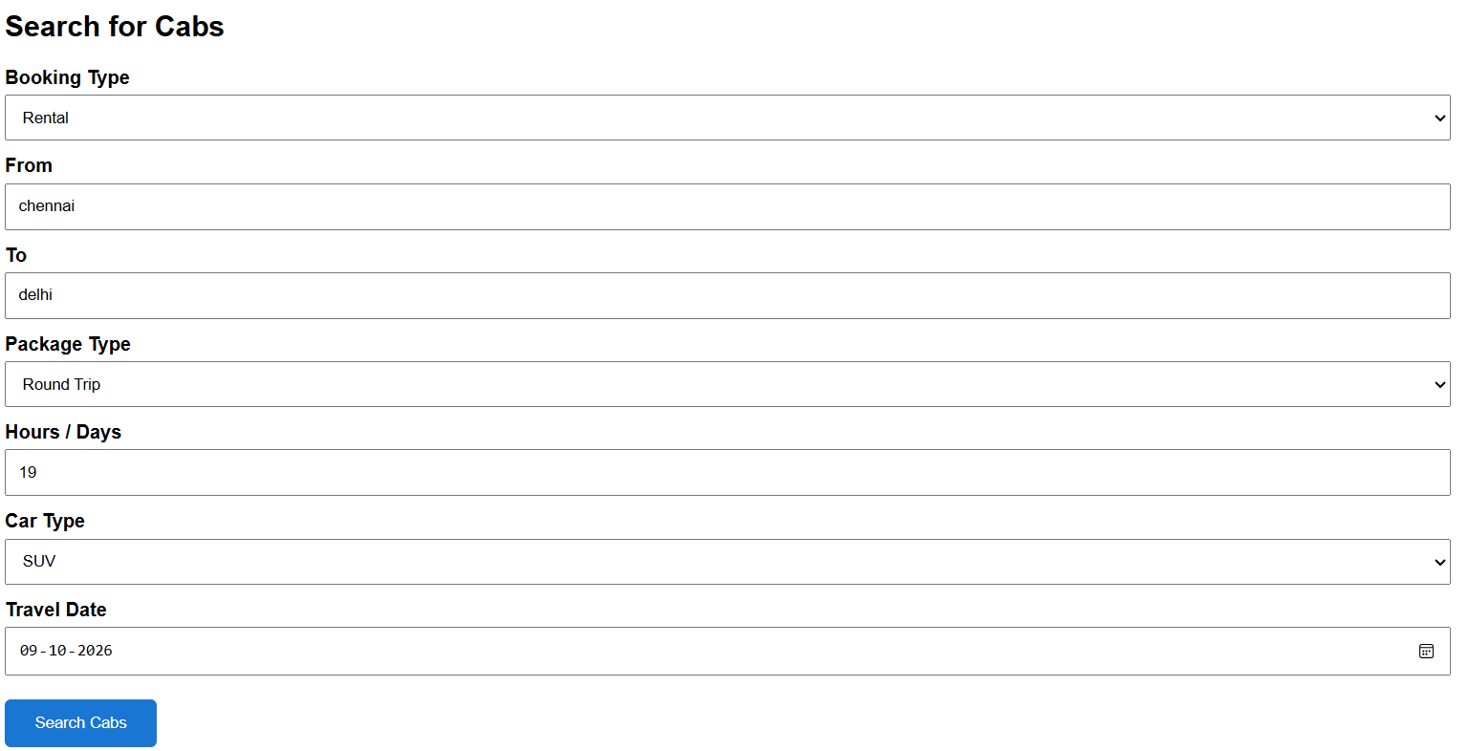
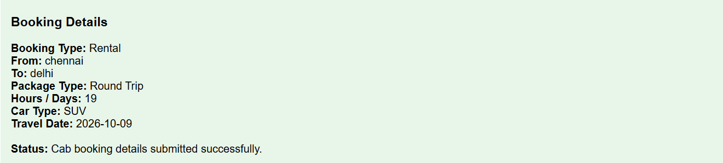
Result
The Car Booking Reservation System was successfully created using HTML. The system accepts the required booking details and displays the cab booking information successfully.

EXPERIMENT-4
Aim
To create a simple cloud-based Library Book Reservation System for SIMATS Library using HTML to demonstrate SaaS, with details such as title, author, publication, year, edition, copies, rack number, and book status.
Algorithm
- Start the application.
- Enter the book title.
- Enter the author name.
- Enter the publication name.
- Enter the publication year.
- Enter the edition.
- Enter the number of copies.
- Enter the rack number.
- Select the book status.
- Select Reserve or Cancel Reservation.
- Click Reserve Book.
- Display the book details.
- Stop.
Pseudo Code
START
Open Library Book Reservation System
Enter Book Title
Enter Author
Enter Publication
Enter Year
Enter Edition
Enter Number of Copies
Enter Rack Number
Select Status
Select Reservation
Click Reserve Book
Display Book Details
STOP
Output
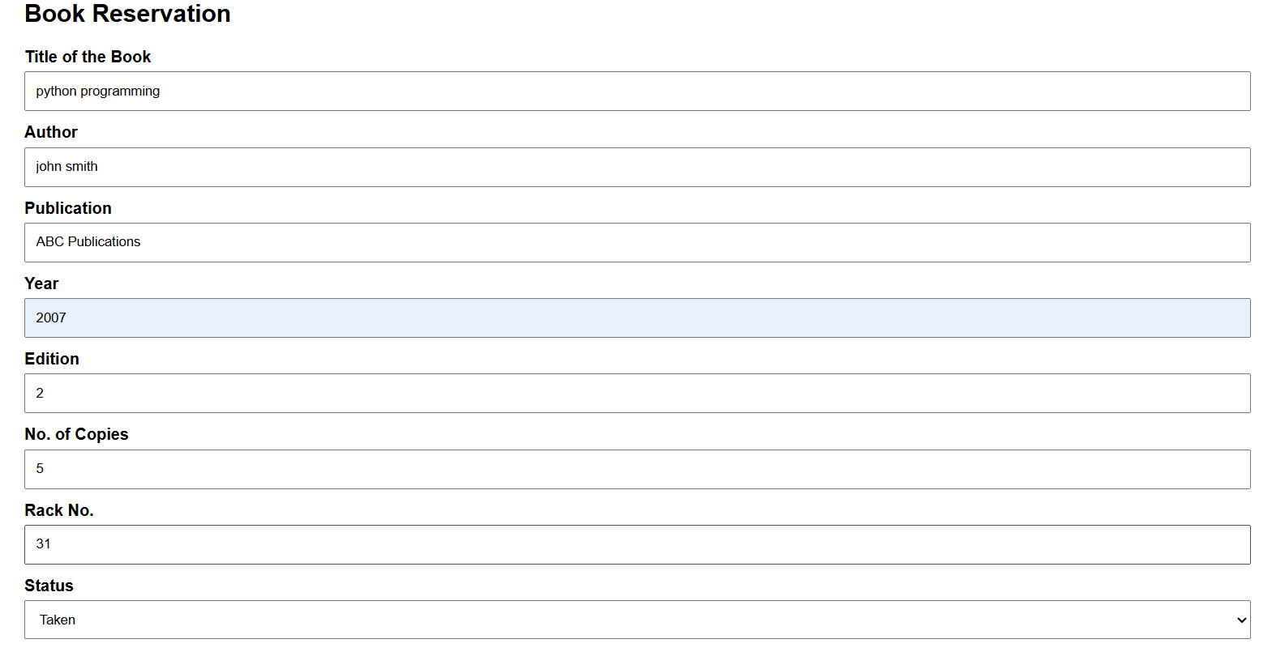
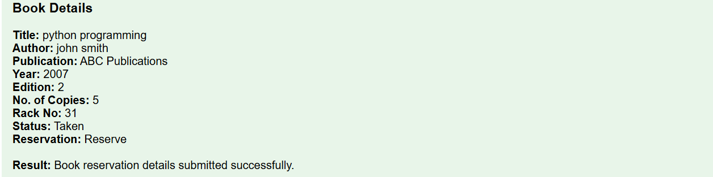
Result
The SIMATS Library Book Reservation System was successfully created using HTML. The system accepts the required book details and displays the book reservation information successfully.

EXPERIMENT-5
Aim
To create a simple cloud-based Mark Sheet Processing System using HTML to demonstrate SaaS, with student name, register number, subject marks, average, percentage, rank, and overall performance.
Algorithm
- Start the application.
- Enter student name.
- Enter register number.
- Enter marks for five subjects.
- Calculate total marks.
- Calculate average marks.
- Calculate percentage.
- Determine overall performance.
- Display the mark sheet.
- Stop.
Pseudo Code
START
Open Mark Sheet Processing System
Enter Student Name
Enter Register Number
Enter Subject Marks
Calculate Total Marks
Calculate Average
Calculate Percentage
Find Overall Performance
Display Mark Sheet
STOP
Output
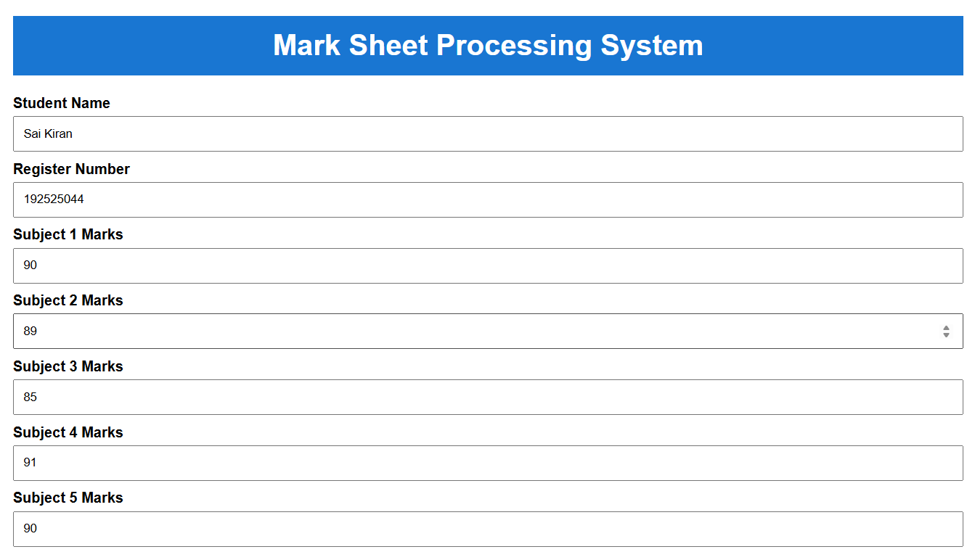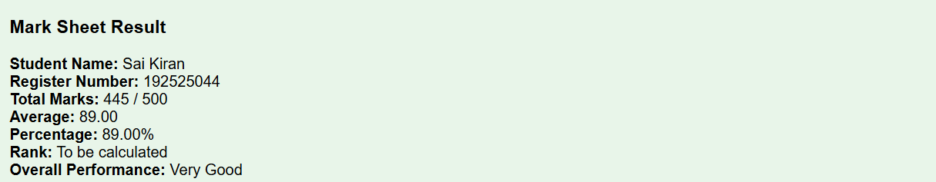
Result
The Mark Sheet Processing System was successfully created using HTML. The system calculates and displays the total marks, average, percentage, rank, and overall performance of the student successfully.

EXPERIMENT-6
Aim
To create a simple cloud-based Payroll Processing System using HTML to demonstrate SaaS, with employee details, salary components, deductions, gross pay, and net pay.
Algorithm
- Start the application.
- Enter employee ID and name.
- Enter department and designation.
- Enter present organization experience.
- Enter overall experience.
- Enter Basic Pay, HRA, DA, TA, and Bonus.
- Enter PF, Tax, and Other Deductions.
- Calculate Gross Pay.
- Calculate Total Deduction.
- Calculate Net Pay.
- Display the payroll report.
- Stop.
Pseudo Code
START
Open Payroll Processing System
Enter Employee ID
Enter Employee Name
Enter Department
Enter Designation
Enter Present Organization Experience
Enter Overall Experience
Enter Basic Pay
Enter HRA
Enter DA
Enter TA
Enter Bonus
Enter PF
Enter Tax
Enter Other Deduction
Calculate Gross Pay
Calculate Total Deduction
Calculate Net Pay
Display Payroll Report
STOP
Output
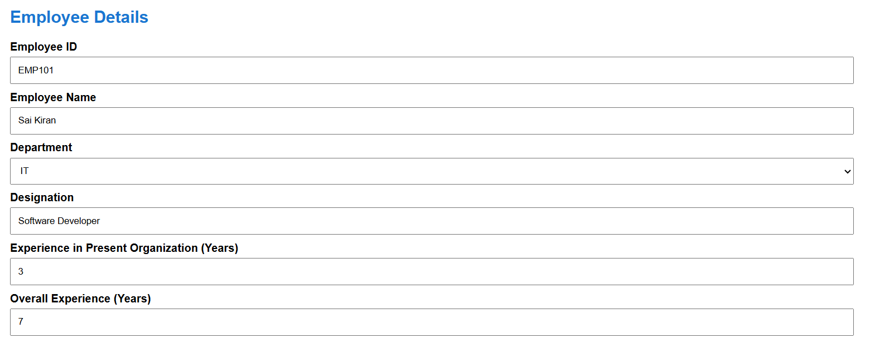
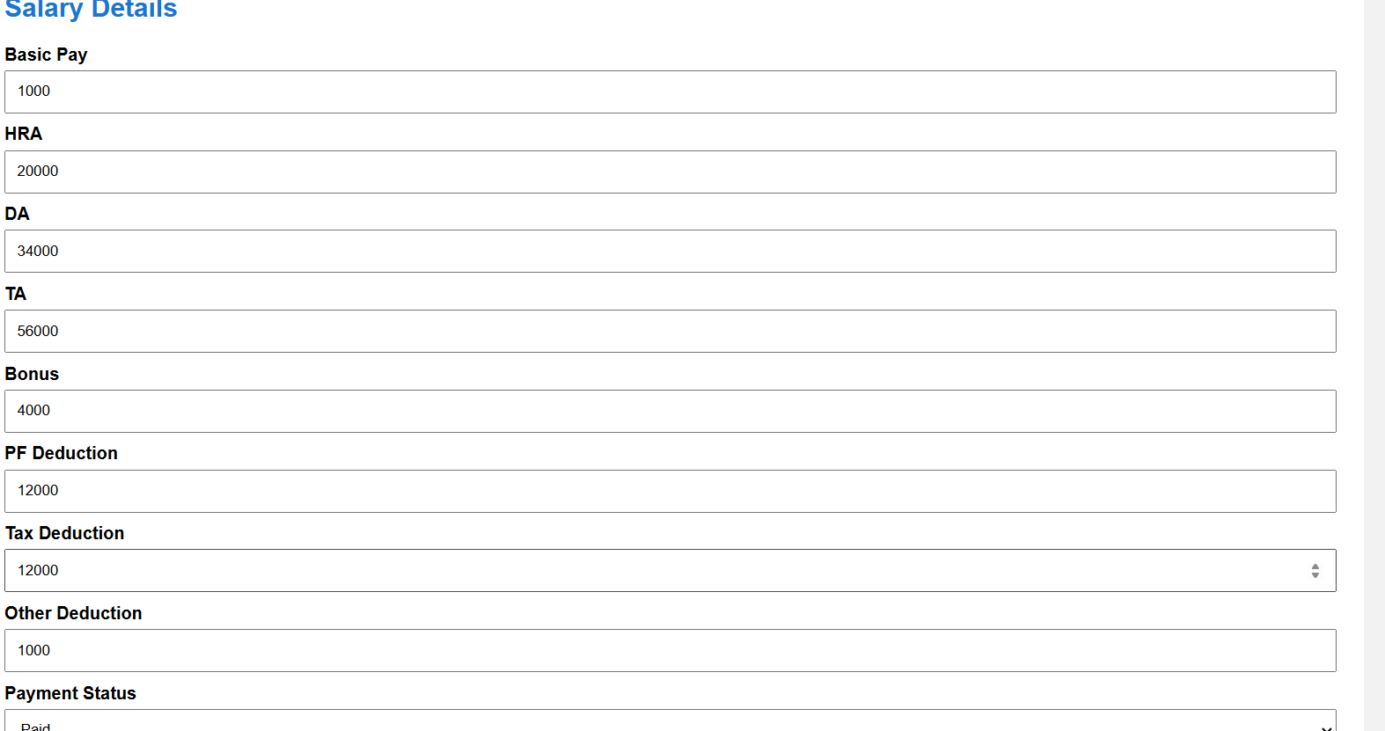
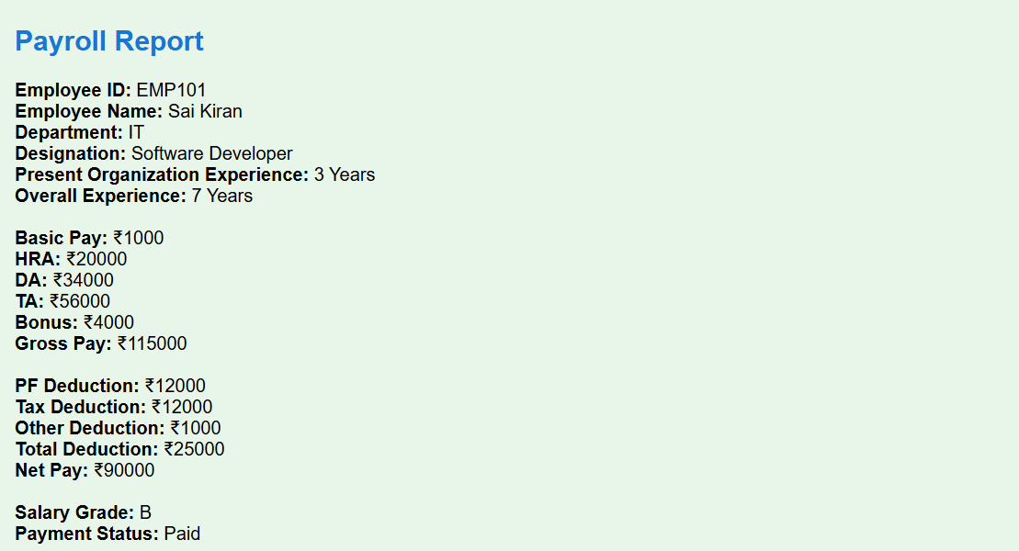
Result
The Payroll Processing System was successfully created using HTML. The system calculates and displays the Gross Pay, Total Deduction, Net Pay, Salary Grade, and Payment Status successfully.

EXPERIMENT-7
Aim
To create a simple cloud-based Students Attendance System using HTML to demonstrate SaaS, with student details, course, present days, absent days, OD request, grade, and attendance percentage.
Algorithm
- Start the application.
- Enter student name.
- Enter register number.
- Select the course.
- Enter total working days.
- Enter present days.
- Enter absent days.
- Select OD request.
- Select grade.
- Calculate attendance percentage.
- Check attendance eligibility.
- Display the attendance report.
- Stop.
Pseudo Code
START
Open Students Attendance System
Enter Student Name
Enter Register Number
Select Course
Enter Total Working Days
Enter Present Days
Enter Absent Days
Select OD Request
Select Grade
Calculate Attendance Percentage
Check Attendance Eligibility
Display Attendance Report
STOP
Output
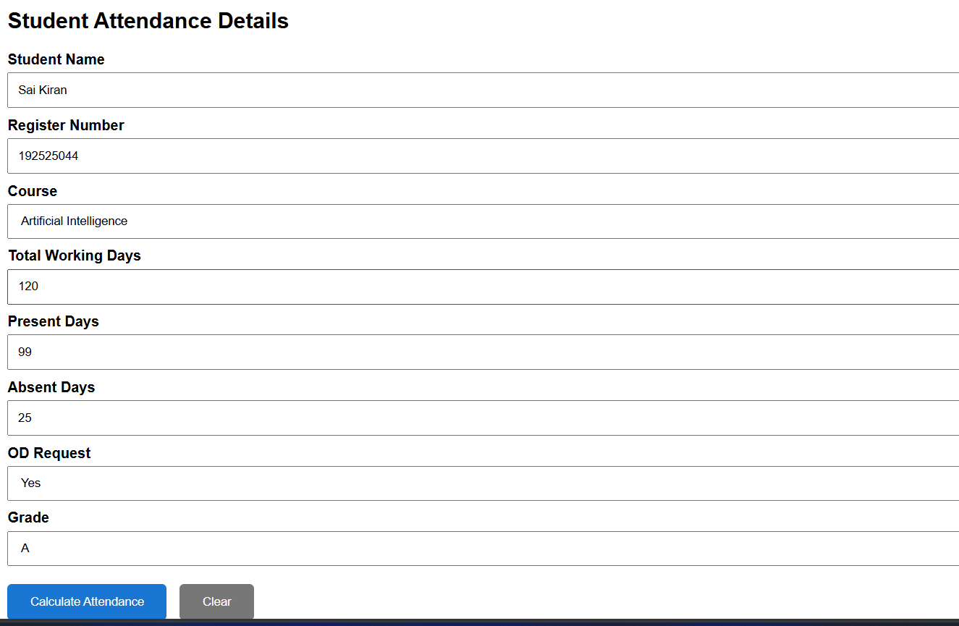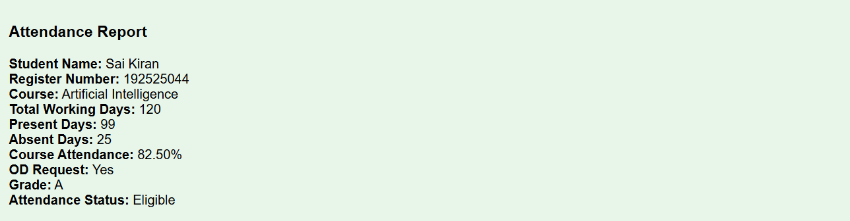
Result
The Students Attendance System was successfully created using HTML. The system calculates and displays the attendance percentage, OD request, grade, and attendance eligibility successfully.

EXPERIMENT-8
Aim
To create a simple cloud-based Student Counselling System using HTML to demonstrate SaaS, with student details, academic information, domain interest, and counselling recommendations.
Algorithm
- Start the application.
- Enter student name.
- Enter age, address, and phone number.
- Enter subjects studied.
- Enter year of passing.
- Enter percentage of marks.
- Select domain interest.
- Select counselling type.
- Generate counselling recommendation based on percentage.
- Display the counselling report.
- Stop.
Pseudo Code
START
Open Student Counselling System
Enter Student Name
Enter Age
Enter Address
Enter Phone Number
Enter Subjects Studied
Enter Year of Passing
Enter Percentage
Select Domain Interest
Select Counselling Type
Generate Recommendation
Display Counselling Report
STOP
Output
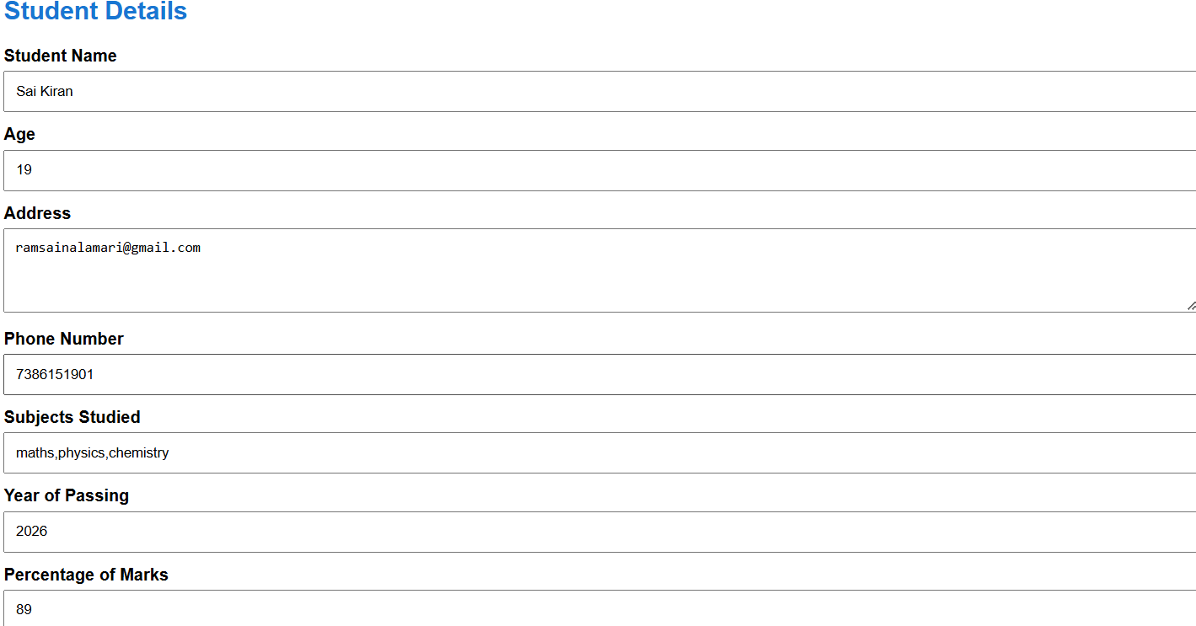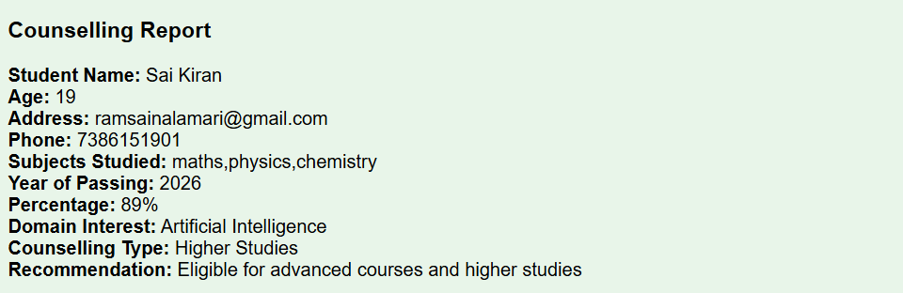
Result
The Student Counselling System was successfully created using HTML. The system accepts student details and generates a counselling report with domain interest and suitable recommendations successfully.

EXPERIMENT-9
Aim
To create a simple cloud-based Hospital Information System for SIMATS Hospital using HTML to demonstrate SaaS, with patient, attender, doctor, disease, and appointment details.
Algorithm
- Start the program.
- Open the SIMATS Hospital Information System.
- Enter patient name and age.
- Select gender.
- Enter address, phone number, and email.
- Enter attender name and attender phone.
- Enter doctor name and select department.
- Enter disease or health problem.
- Enter appointment date.
- Select patient type.
- Submit the details.
- Display the hospital information.
- Stop the program.
Pseudo Code
START
Open Hospital Information System
Enter Patient Name
Enter Age
Select Gender
Enter Address
Enter Phone Number
Enter Email
Enter Attender Name
Enter Attender Phone
Enter Doctor Name
Select Department
Enter Disease
Enter Appointment Date
Select Patient Type
Submit Patient Details
Display Hospital Information
STOP
Output
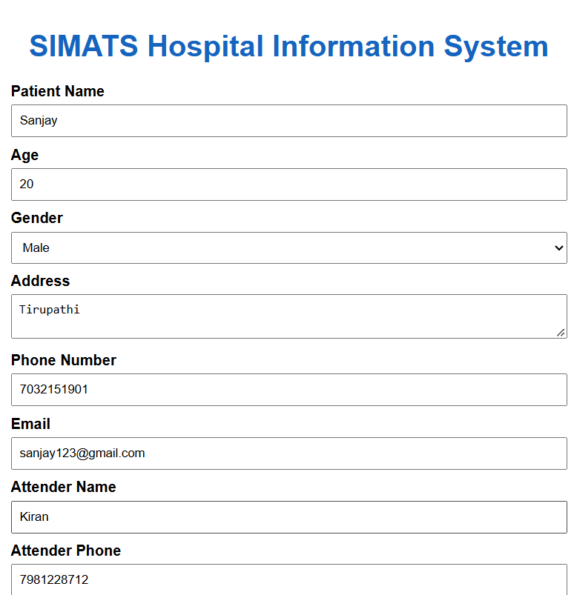
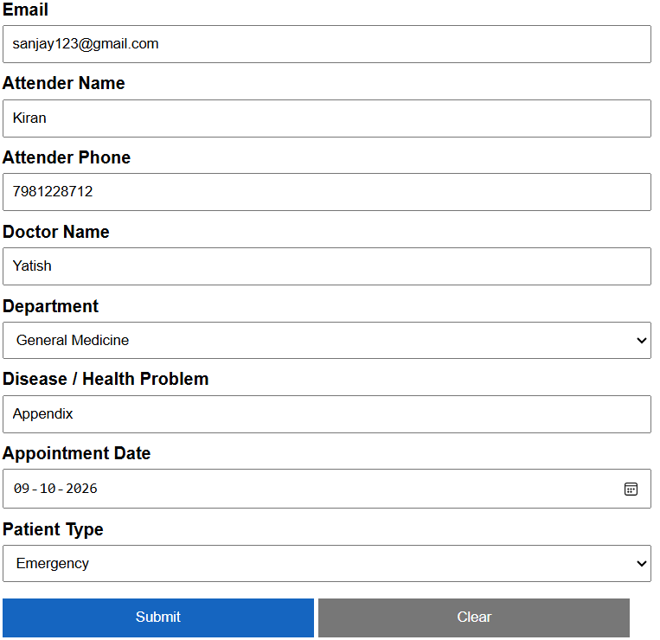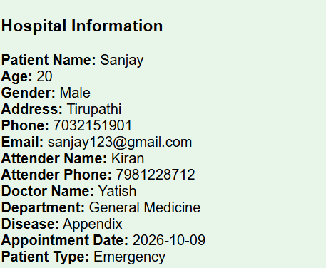
Result
The SIMATS Hospital Information System was successfully created using HTML. The system accepts patient, attender, doctor, disease, and appointment details and displays the hospital information successfully.

EXPERIMENT-10

Aim
To create a simple cloud-based Student Information System using HTML to demonstrate SaaS, with student name, register number, address, phone, age, course, grades, attendance, progress report, and semester mark sheet details.
Algorithm
- Start the program.
- Open the Student Information System.
- Enter student name and register number.
- Enter address, phone number, and age.
- Select the course.
- Enter grade and attendance percentage.
- Select the progress report.
- Enter semester marks.
- Submit the student details.
- Display the complete student information report.
- Stop the program.
Pseudo Code
START
Open Student Information System
Enter Student Name
Enter Register Number
Enter Address
Enter Phone Number
Enter Age
Select Course
Select Grade
Enter Attendance Percentage
Select Progress Report
Enter Semester Marks
Submit Student Details
Display Student Information Report
STOP
Output
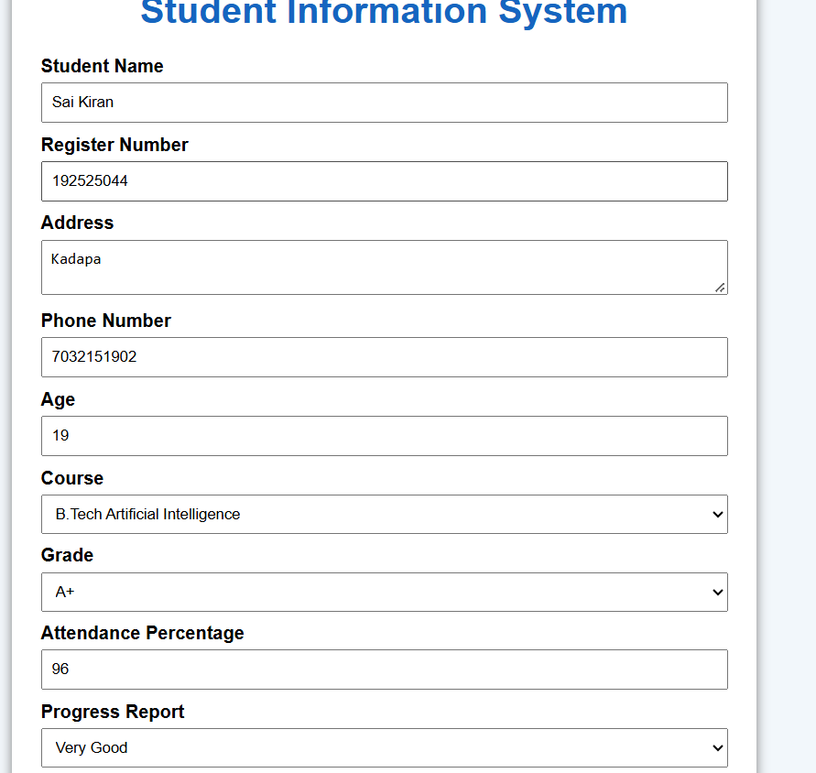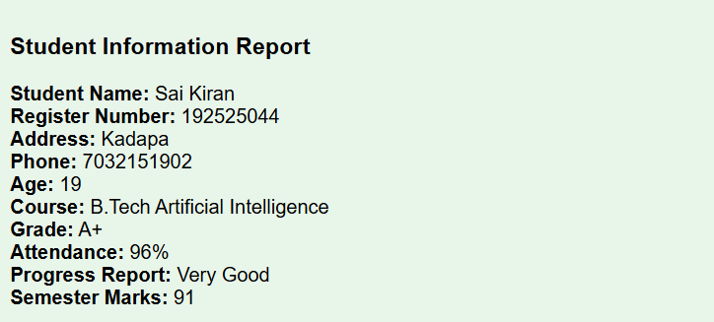

Result
The Student Information System was successfully created using HTML. The system accepts student details, grades, attendance, progress report.

EXPERIMENT-11
Aim
To create a simple cloud-based Online Super Market System using HTML to demonstrate SaaS, with customer details, item classification, item name, quantity, and payment details.
Algorithm
- Start the program.
- Open the Online Super Market System.
- Enter customer name.
- Enter address, phone number, and email.
- Select the item classification.
- Enter item name.
- Enter quantity and select unit.
- Select payment method.
- Place the order.
- Display the order details.
- Stop the program.
Pseudo Code
START
Open Online Super Market
Enter Customer Name
Enter Address
Enter Phone Number
Enter Email
Select Item Classification
Enter Item Name
Enter Quantity
Select Unit
Select Payment Method
Place Order
Display Order Details
STOP
Output
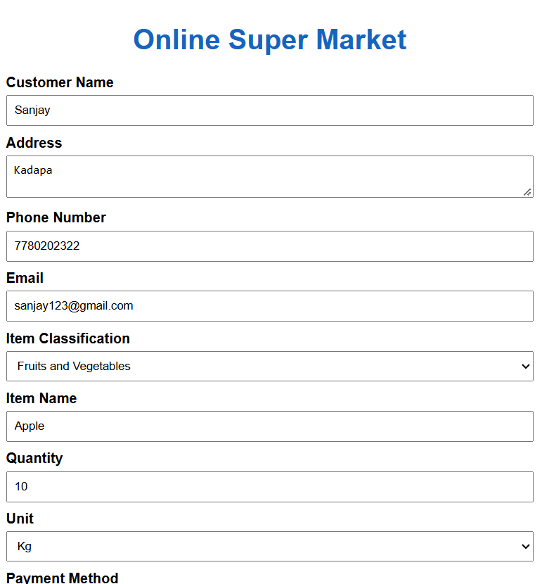
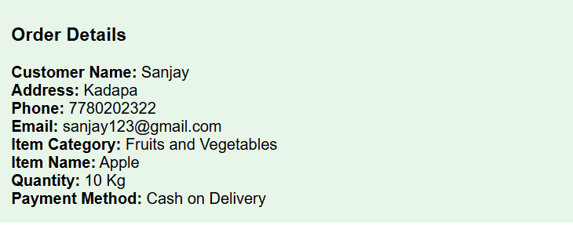

Result
The Online Super Market System was successfully created using HTML. The system accepts customer details, classifies items, accepts quantity and payment details, and displays the order information successfully.

